**Introduction**

The Internet of Things Implementation (TC1004B) is a course from Tecnológico de Monterrey[1] based on the TEC21 model[2]. It aims to introduce the main IoT foundations. For ten weeks, students design and implement a digital system prototype that can obtain data through sensors, process their information, and present them on an internet platform for later analysis and visualization. During this period, students will achieve the following skills:

* Elaboration and development of digital systems.
* Analysis, design, and development of databases.
* Resource management of a computer system through the efficient use of resources.
* Introduction to Interactive Design.
* Processes and project management.
* Analysis, design, and development of IoT systems.

The course has six modules: Digital Systems, Database Design and Analysis, Resource Management of a Computer System; Introduction to Interactive Design; Project Management and Processes, and Internet of Things.

This year the course will be performed inside the Global Shared Learning Classroom[3] program, an initiative of the Vice Rectory for International Affairs that promotes collaboration between students, professors, and international universities in a digital environment and with the use of technological tools. Global Shared Learning (GSL) is an opportunity to generate international experiences with meaningful learning.

The partner university is the Instituto Tecnológico de Aeronáutica[4], which is a public university institution linked to the Air Force Command and is in São José dos Campos (São Paulo). ITA was created in 1950 and is considered a reference center in engineering education in Brazil. It was inspired by MIT (Massachusetts Institute of Technology) in the United States. It was the embryo of companies such as Embraer, IACIT, and Avibras, which developed aircraft, advanced defense, and air traffic systems for governments worldwide.

The collaboration focuses on developing the student’s sense of cooperation needed to solve a complex problem through a multicultural partnership. The implementation of GSL will happen in the performance of the TC1004B “reto” project during the second part of the course (weeks 13 to 17). The selected scenario is a disaster situation (ex.: an earthquake in Mexico and flooding in Brazil), a prevalent worldwide problem. In this scenario, you do not have telecommunication channels or any previous Command and Control (C2) system to provide rescue teams with essential communication (voice and data), planning, and execution services. Consequently, it is required to use the means existent in the community and by volunteers, for example, the use of drones to improve communication and support the identification of hazards.

The sustainable development goal is the “Industry, Innovation, and Infrastructure” and “Sustainable Cities and Communities,” where the group will work to build a resilient infrastructure when there is a natural hazard.

**Scenario Description**

Every year, disasters and crises devastate people, communities, and entire societies worldwide. Worryingly, they are predicted to become more common in the future. Disasters can occur naturally (e.g., tornadoes, hurricanes, earthquakes, floods, wildfires, mudslides, or drought) or be human-caused (e.g., mass shootings, chemical spills, or terrorist attacks). Preparing for, responding to, and recovering from disasters and traumatic events is essential to individuals’ and communities' behavioral health.

When people experience a disaster, they may experience a variety of reactions, many of which are natural responses to challenging situations. Most people show resilience after a disaster. Resilience is the ability to bounce back, cope with adversity, and endure demanding conditions. Thankfully, resilience in disaster recovery is ordinary, not extraordinary, and people regularly demonstrate this ability. Supportive resources to address stress and other hardships are a critical component of resilience.

Like war, disasters are also much unstructured in scope. No one can predict the exact time and how a disaster will strike. Sometimes the local infrastructure is devasted, and there are no telecommunication resources available to provide the essential communication necessities, for example, providing means to the affected communities asking for help. Usually, this type of situation requires a complete telecommunication infrastructure to provide Command and Control[5] to support the operations.

We use a flooding scenario to support the course in the project development. Because the changes to our climate and environment are already contributing to the increased frequency, intensity, and unpredictability of severe weather events, what makes this type of disaster usually in tropical countries like Brazil and Mexico, generating many victims and causing fatalities and incalculable losses (financial and social) for the population,

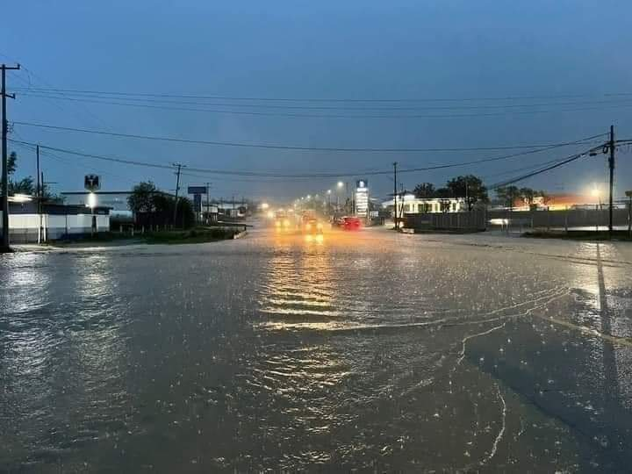

Figure - Flooding in Monterrey, Nuevo León

For example, in November of 2008, Santa Catarina, a state in the south of Brazil, had a period of heavy rainfall (20-23 November). The state had suffered constant rains for over two months, which turned the soil wet enough to cause a landslide during the storm that hit the state in late November. Around 60 towns and over 1.5 million people were affected. At least 128 people have been killed, with over 78,700 forced to evacuate their homes. A further 150,000 have been left without electricity, while water rationing is being carried out in at least one town due to purification problems. Several regions’ cities have become cut off due to floodwater and landslide debris. Water levels in the Vale do Itajaí have risen to eleven meters above normal.

Figure - Flooding in Itajaí 2008[6].

Because of the electrical blackout, many communities were left without communication, which made it difficult for people to call for help and inform where they were. It is the issue that our project will try to solve.

**Solution Description**

The problem to be answered by the Project is how to provide an efficient and secure environment to send a distress message when a natural disaster occurs (in our case, the flood disaster situation). In the scenario, there are no telecommunication links to provide essential communication (voice and data) to the rescue teams. Consequently, it is required to be innovative. It uses the means existent in the community and by volunteers, for example, drones[7], to provide communication resources and support the identification of hazards.

Figure 3 shows the pictorial representation of the scenario. On that, the victims in the flood area will have a smartphone with a rescue app, which enables the citizens to send their position continuously and when they are in danger (severity level message 🡪 high, medium, or low) as a basic text message (description of their situation), as it is presented in Figure 4. To provide communication support (enabling victims’ messages to flow to the Crisis Management Center - CMC), drones flying in the crisis area intercept the message and forward it to other drones until the message arrives at the CMC. The CMC data is processed and aggregated, and a dashboard is provided for the operators to plan the rescue operation efficiently.

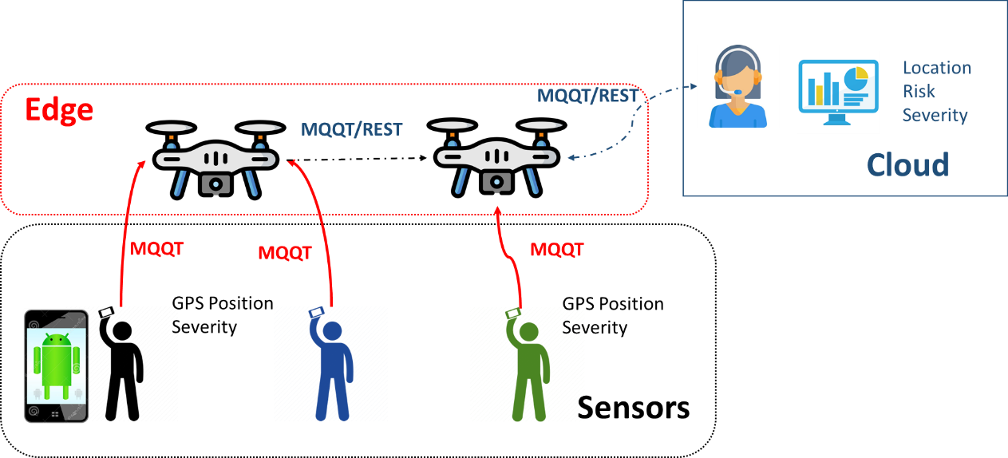

Figure - Implementation Definition.

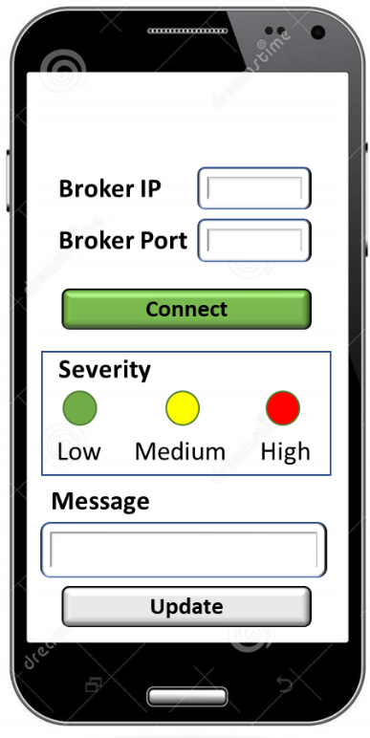

Figure - Android App

The approach used to implement the solution is through an Internet of Things (IoT) architecture. IoT is an advanced automation and analytics system that deals with artificial intelligence, sensor, networking, electronic, cloud messaging, etc., to deliver complete systems for the product or services[8]. You use a four-stage architecture to design the solution and make it easy to understand and interoperable, as presented in Figure 5.

Figure - Four-stage IoT Architecture.

Backing to Figure 1, it is easy to understand that the Edge and Gateway layers are provided by the Drones, which implement an MQTT broker to forward the messages from the Android devices to CMC, which is hosted in the cloud. The message protocol selected is the MQTT. MQTT[9] is an OASIS standard messaging protocol for the Internet of Things (IoT). It is designed as an extremely lightweight publish/subscribe messaging transport ideal for connecting remote devices with a small code footprint and minimal network bandwidth. MQTT today is used in various industries, such as automotive, manufacturing, telecommunications, oil & gas, etc.

**Project Method Implementation**

The Above scenario will be collaboratively developed by both groups (ITA & TEC), where the TEC is responsible for developing the IoT environment (C2 dashboard, victim device, and other IoT infrastructure). In contrast, the ITA will create the network environment (using a simulator).

The activity will be performed in 5 weeks, and the last one is the project workshop, which follows the GSL methodology, as shown in Figure 6. Following this methodology, the work will be implemented in 3 activities: Icebreaker, Collaboration, and Reflection. These activities are described in tables 1, 2, and 3.

Figure - GSL Methodology.

Table - Icebreaker Activity.

|  |  |  |  |
| --- | --- | --- | --- |
| **Task** | **Due Date** | **Weight Reto** | **Description** |
| Step 1: Icebreaker Video | 3/11 | 5% | Make a video introducing yourself (1-3 minutes) where you tell us about yourself, who you are, where you are from, what you are studying, what you like to do in your spare time, and what are some of your interests or passions, and your future. Try to focus on what your international peers (you suppose) do not know about you, your city, your country, and your school.  Try to get the group’s attention - remember this is your opportunity to meet interesting people worldwide. Feel free to express yourself; this is a safe place we all respect. |
| Step 2: Reply To Your Peers | 4/11 | 5% | Ok! Let's keep working! Once you have posted your message, reply to at least two other students you don’t know, and comment on what they find attractive about their posts.  The follow-up posts should consist of one well-crafted paragraph, including an introductory sentence and finishing a section with a concluding statement or question.  Did you find something interesting in your peer's post? Do you observe any differences or similarities with your peers? Do you have any advice for them?  After someone comments on your post, reply or react to the observations received. |

Table - Collaborative Activity.

|  |  |  |  |  |
| --- | --- | --- | --- | --- |
| **Task** | **Due Date** | **Weight Reto** | | **Description** |
| Step 1: Project Setup | 11/11 | 10% | During this activity, the students will identify the technical and non-technical requirements of the project using user stories, write the requirement documents, set the project in GitHub, design the basic architecture using UML, and define the essential ceremonies required for a well-organized project. Finally, the students will create a README file following these approaches:   * <https://github.com/othneildrew/Best-README-Template> * <https://www.freecodecamp.org/news/how-to-write-a-good-readme-file/> | |
| Step 2: Smart Sensor / Drones and Connectivity | 18/11 | 10% | During this activity, the students will implement the required app and integrate it with the drones in the emulated environment. Also, the students will update the README file and the other required documentation on GitHub. | |
| Step 3: IoT Network & P2p Drone Network | 25/11 | 10% | During this activity, the students will analyze the best options to implement the IoT Network as the P2P drone network. They will develop the Command & Control Dashboard and functionalities to provide situation awareness to the Rescue Teams. Also, the students will update the documentation on GitHub. | |
| Step 4: Final Presentation | 2/12 | 50% | During this activity, the students will finalize the system, summarize their findings in the documentation file, and produce a HOWTO document showing how to set up and use the system. Also, they will participate in a seminar, where each group will present its result to an evaluation committee. | |

Table – Reflection Activity.

|  |  |  |  |  |
| --- | --- | --- | --- | --- |
| **Task** | **Due Date** | **Weight Reto** | | **Description** |
| Reflection | 2/12 | 10% | Just as you did during the Icebreaker, go to the assigned Padlet-board and create a new video sharing your thoughts about our experience considering the following:     * How do you think your cultural background impacts how you interact and negotiate with others? * Has collaboration with international peers impacted your learning experience? * After this experience, are there any changes in your worldview?     You don't have to answer each question individually; it would be better to take these questions as a guide to constructing a complete reflection.  Remember, posting a video (1-3 min max) will be great, but you can also post it as a text (no text limit). | |

1. <https://tec.mx/en>
2. <https://tec21connect.com/>
3. <https://global.tec.mx/en/global-shared-learning>
4. <http://www.ita.br/>
5. Tammineedi, Rama Lingeswara. "Business continuity management: A standards-based approach." Information Security Journal: A Global Perspective 19.1 (2010): 36-50.
6. By http://www.agenciabrasil.gov.br/media/imagens/2008/11/26/bairrocarvalho.jpg/view, CC BY 3.0 BR, https://commons.wikimedia.org/w/index.php?curid=5289364
7. https://safetymanagement.eku.edu/blog/5-ways-drones-are-being-used-for-disaster-relief/
8. Patel, Keyur K., Sunil M. Patel, and P. Scholar. "Internet of things-IOT: definition, characteristics, architecture, enabling technologies, application & future challenges." International journal of engineering science and computing 6.5 (2016).
9. Standard, O. A. S. I. S. "MQTT version 3.1. 1." URL http://docs. oasis-open. org/mqtt/mqtt/v3 1 (2014): 29.